**SCHOOLZWEMMEN** 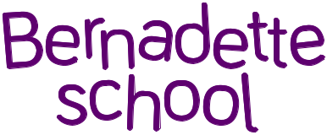

Schooljaar 2024-2025

Er is schoolzwemmen tijdens volgende weken :

16/09/2024 – 20/09/2024

30/09/2024 – 04/10/2024

14/10/2024 – 18/10/2024

11/11/2024 – 15/11/2024

25/11/2024 – 29/11/2024

09/12/2024 – 13/12/2024

06/01/2025 – 10/01/2025

20/01/2025 – 24/01/2025

03/02/2025 – 07/02/2025

17/02/2025 – 21/02/2025

17/03/2025 – 21/03/2025

31/03/2025 – 04/04/2025

28/04/2025 – 02/05/2025

12/05/2025 – 16/05/2025

26/05/2025 – 30/05/2025

09/06/2025 – 13/06/2025

23/06/2025 – 27/06/2025